Public Address (PA) System 60W Mixer Amplifier with wifi, bluetoth, MP3
FA-60WF

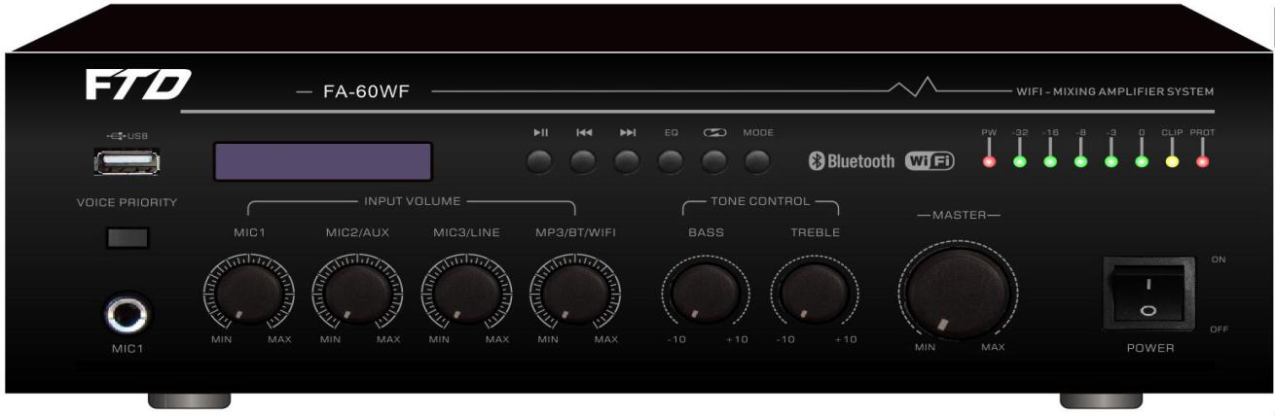

Description:
The Public Address (PA) Mixer Amplifier is suitable for school, super market, bank, hotel BGM and speech use.

It is integrate pre amplifier, Mp3 player and mixer power amplifier into one mini tabletop design, which is
economy but of high reliable performance..

The tabletop mixer amplifier rated power out at 60W. Its speaker outputs with 100V, 70V and 4‐16ohms for versatile connections.

This amplifier is with wifi module build in, easy to connect more phone for operation, use phone APP to control more than 100amplifier to play BGM music from phone.

It integrates three inputs. Mic1 VOX with priority. Microphone1 on front panel by phone jack, microphone2‐3, line 1‐2 on rear panel is switchable .

The amplifier is design with complete protection of overload, short circuit and high temp to avoid any damage.

Features:
- Public address (PA) tabletop mixer power amplifier.
- Commercial & industrial range BGM & paging amplifier.
- Mixer amplifier built-in Mp3 player by USB.
- Rated outputs of 60W
- 70V, 100V and low impedance 4-16 ohms speaker outputs.
- 1 microphone inputs and 2 line inputs with switchable to Mic input.
- Mic1 on front panel by phone jack, mic2-3 on rear panel .
- Wifi amplifier support phone APP to control, if two phone connect same amplifier, latest one is higher priority.
- Overload, short circuit and high temp protection.
- With natural cooling fan to control the internal temperature.
- Warranty of 3 years with CE certificate.

Public Address (PA) System 60W Mixer Amplifier with wifi, bluetoth, MP3
FA-60WF

Specification:
Model | FA-60WF  FA-120M  FA-240M  FA-350M  FA-500M
Description | Public Address System 60W Mixer Amplifier
Rated Power Output | 60W  120w  240w  350w  500
Speaker Output | 70V, 100V and 4-16Ω
Input | Mic1: 600 ohms(Ω) 5-8 mV, unbalanced, Line1-2(MIC 2-3): 10k ohms(Ω) 150-470 mV, Balance  unbalanced
Frequency Response | 60-15KHz
THD | <0.5% at 1kHz, 1/3 rated power
S/N Ratio | Line: 85 dB , MIC: >72 dB
Protection | High temp, short circuit, overload protection
Power Supply | AC230V or AC110V, 50-60Hz
Power Consumption | 95W  175W  350W  485W  650W
Dimension | 75(H)x280(W)x240(D)mm
Net. Weight | 5.6kg  11.4kg  13.7kg  14.1kg  16.5kg
Gross Weight | 6.5kg  13.1kg  15.4kg  15.8kg  17kg
Warranty | 3 years

